Creating a Starter Project Template

creating a starter project template is a great way to streamline development and ensure consistency across projects. To begin, it's important to set up a clean and well-organized project structure tailored to the type of application, such as Flutter, web, or backend projects. Pre-configuring common dependencies and adding boilerplate code, like a basic navigation system for Flutter or initial API routes for a backend, can save time and effort later. Incorporating useful tools like environment variables, a .gitignore file, and linters ensures the project remains maintainable. Additionally, including a README.md file with setup instructions and best practices makes it easier for others (or yourself) to reuse the template. Automating tasks with scripts for running, testing, or building the project further improves efficiency. Finally, saving the template in a Git repository or turning it into a custom CLI tool makes it easily accessible for future use or for sharing with a team.

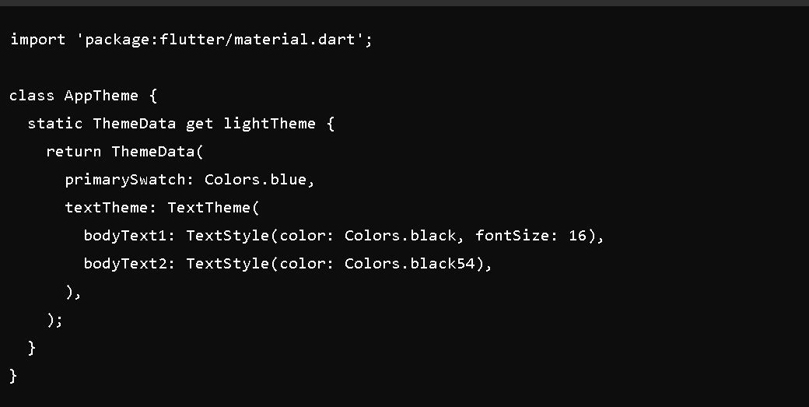

Add a launch.json file in the .vscode/ folder (if using VS Code) for debugging:

